Student Name : Anisetti Surendra Krishna
Registration Number : 192472202
Course Code & Name : MLA0302 - Reinforcement Learning
Date of Submission : 14-11-2024

Experiment 1: Installation of RL Development Environment

Aim :
To install and configure the Reinforcement Learning (RL) development environment using Anaconda Navigator, Python, TensorFlow, Keras, Gymnasium (OpenAI Gym), NumPy, Matplotlib, and other required libraries, and verify the installation by executing a simple Reinforcement Learning program.

Procedure :
Step 1 : Download and install Anaconda Navigator on your computer.
Step 2 : Open Anaconda Prompt and create a new Python environment.
Step 3 : Install the required libraries using the pip command:
pip install gymnasium tensorflow keras numpy matplotlib
Step 4 : Open Spyder, Jupyter Notebook, or VS Code from the created environment.
Step 5 : Write a simple Reinforcement Learning program to create a Gymnasium environment and run a few steps.
Step 6: Execute the program and verify that the environment runs successfully without errors.
Result :
The Reinforcement Learning development environment was successfully set up and verified. The required libraries, including Python, TensorFlow, Keras, Gymnasium (OpenAI Gym), NumPy, and Matplotlib, were installed and imported successfully. A CartPole-v1 environment was created, random actions were executed, and the environment was rendered successfully. This confirms that the Reinforcement Learning environment is properly configured and ready for developing and testing RL algorithms.

Code :
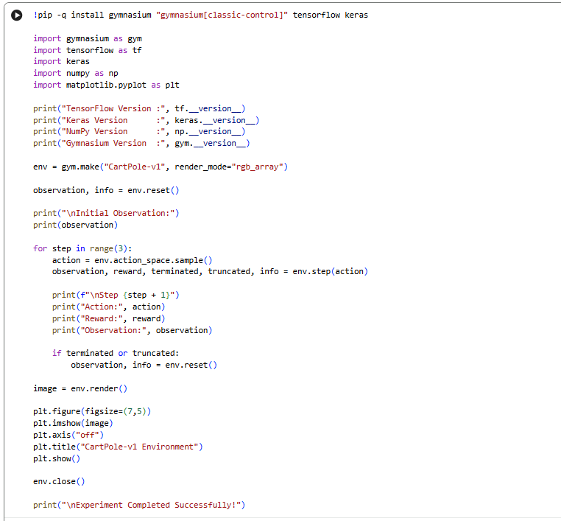
Output :
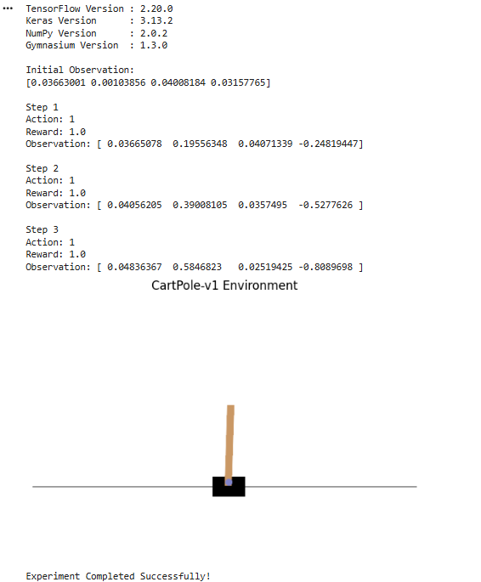
Experiment 2: Familiarization with OpenAI Gym/Gymnasium Environments

Aim:
To create, initialize, and interact with standard Reinforcement Learning
environments such as FrozenLake, CartPole, and MountainCar using Gymnasium to
understand the concepts of states, actions, rewards, and episodes.

Procedure :
Step 1 : Download and install Anaconda Navigator on your computer.
Step 2 : Open Anaconda Prompt and create a new Python environment.
Step 3 : Install the required libraries using the pip command:
pip install gymnasium tensorflow keras numpy matplotlib
Step 4 : Open Spyder, Jupyter Notebook, or VS Code from the created environment.
Step 5 : Write a simple Reinforcement Learning program to create a Gymnasium environment and run a few steps.
Step 6: Execute the program and verify that the environment runs successfully without errors.

Result :
The Gymnasium CartPole-v1 environment was successfully created and executed. The observation space, action space, and initial state were displayed correctly. The agent performed random actions, and the corresponding observations and rewards were obtained for each step. The environment was rendered successfully using Matplotlib, confirming that the Gymnasium environment is functioning correctly and can be used for implementing and testing Reinforcement Learning algorithms.

Code :
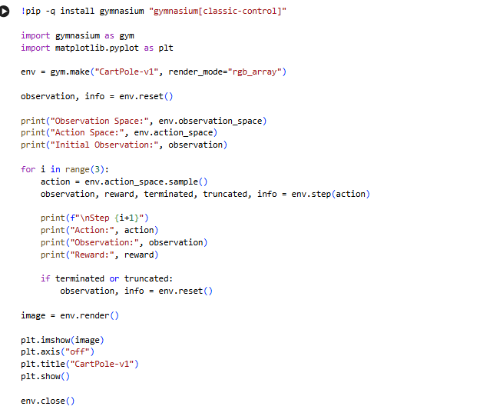
Output :
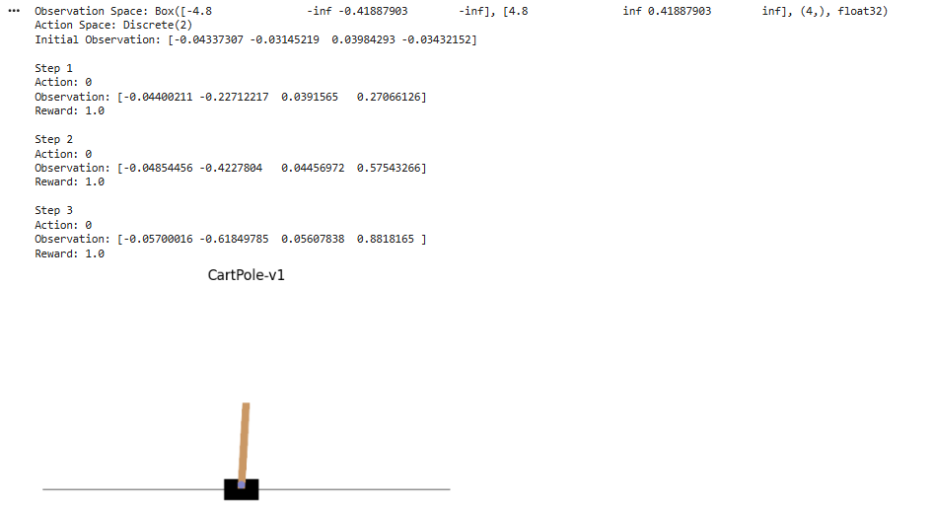

Experiment 3: Implementation of the Reinforcement Learning Framework

Aim:
To implement the basic Reinforcement Learning framework by designing an agent that interacts with an environment through states, actions, rewards, and policies using Python.

Procedure :
Step 1 : Download and install Anaconda Navigator on your computer.
Step 2 : Open Anaconda Prompt and create a new Python environment.
Step 3 : Install the required libraries using the pip command:
pip install gymnasium tensorflow keras numpy matplotlib
Step 4 : Open Spyder, Jupyter Notebook, or VS Code from the created environment.
Step 5 : Write a simple Reinforcement Learning program to create a Gymnasium environment and run a few steps.
Step 6: Execute the program and verify that the environment runs successfully without errors.

Code:
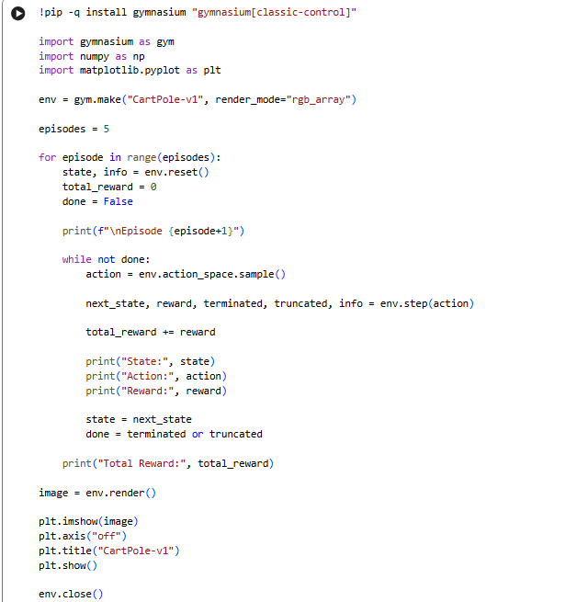
Output:
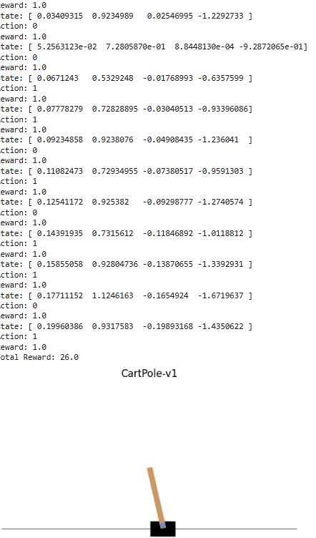

Experiment 4: Simulation of a Markov Decision Process (MDP)
Aim:
To develop a simple Markov Decision Process model and simulate state
transitions, reward functions, and policy execution for understanding sequential
decision-making problems.

Procedure :
Step 1 : Download and install Anaconda Navigator on your computer.
Step 2 : Open Anaconda Prompt and create a new Python environment.
Step 3 : Install the required libraries using the pip command:
pip install gymnasium tensorflow keras numpy matplotlib
Step 4 : Open Spyder, Jupyter Notebook, or VS Code from the created environment.
Step 5 : Write a simple Reinforcement Learning program to create a Gymnasium environment and run a few steps.
Step 6: Execute the program and verify that the environment runs successfully without errors.
Code:
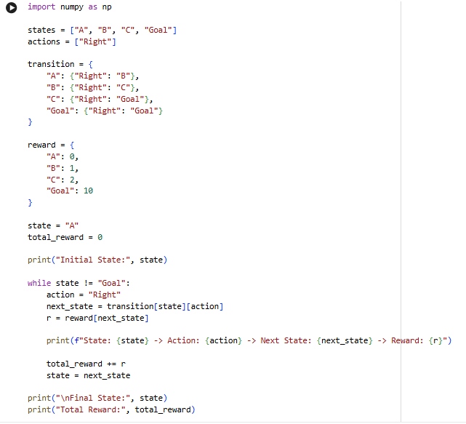
Output :

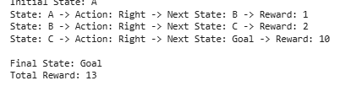

Experiment 5: Bellman Equation Demonstration
Aim:
To implement Bellman Expectation and Bellman Optimality Equations for
calculating state-value and action-value functions and analyze the convergence of
value estimation.

Procedure :
Step 1 : Download and install Anaconda Navigator on your computer.
Step 2 : Open Anaconda Prompt and create a new Python environment.
Step 3 : Install the required libraries using the pip command:
pip install gymnasium tensorflow keras numpy matplotlib
Step 4 : Open Spyder, Jupyter Notebook, or VS Code from the created environment.
Step 5 : Write a simple Reinforcement Learning program to create a Gymnasium environment and run a few steps.
Step 6: Execute the program and verify that the environment runs successfully without errors.
Code :
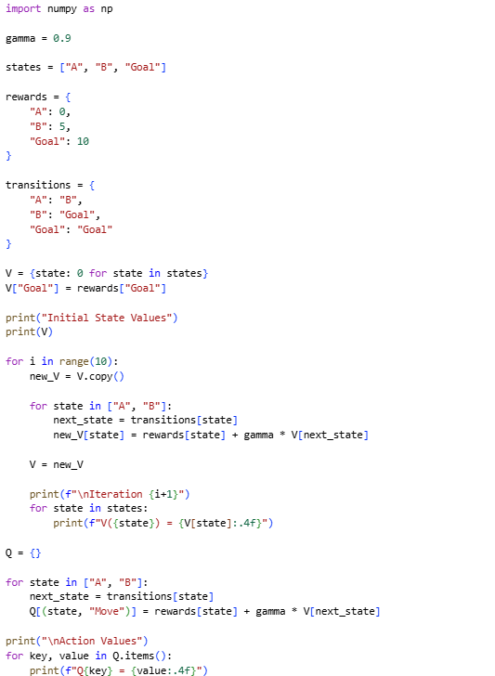
Output :
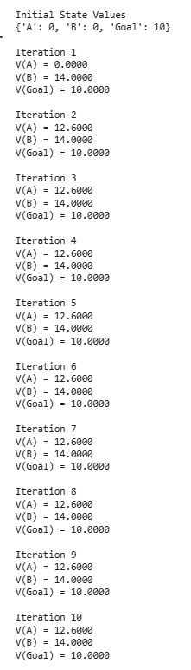

Experiment 6: Exploration vs. Exploitation Strategies

Aim:
To implement ε-Greedy, Greedy, and Random action-selection strategies and compare their performance in balancing exploration and exploitation during Reinforcement Learning.

Procedure :
- Define the available actions and rewards.
- Implement the Random action-selection strategy.
- Implement the Greedy strategy.
- Implement the ε-Greedy strategy.
- Execute each strategy for multiple steps.
- Calculate the total reward obtained by each strategy.
- Compare the performance of all strategies.
Output :
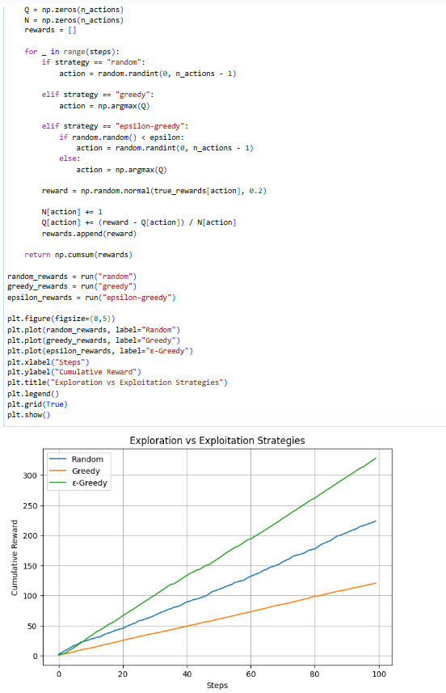

Result:
The Random, Greedy, and ε-Greedy strategies were successfully implemented and compared, demonstrating the trade-off between exploration and exploitation.

Experiment 7: Multi-Armed Bandit Problem

Aim:
To implement the Multi-Armed Bandit problem using ε-Greedy and Upper Confidence Bound (UCB) algorithms and evaluate cumulative rewards obtained by different action-selection methods.

Procedure :
- Define multiple bandit arms with different rewards.
- Initialize the ε-Greedy algorithm.
- Execute actions and update reward estimates.
- Implement the Upper Confidence Bound (UCB) algorithm.
- Execute the UCB action-selection strategy.
- Calculate cumulative rewards.
- Compare the performance of ε-Greedy and UCB.

Code :
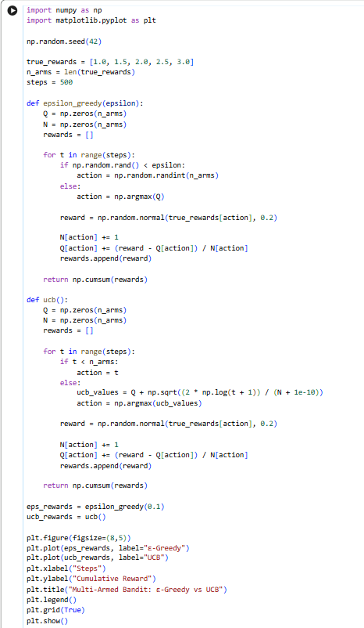

Output:
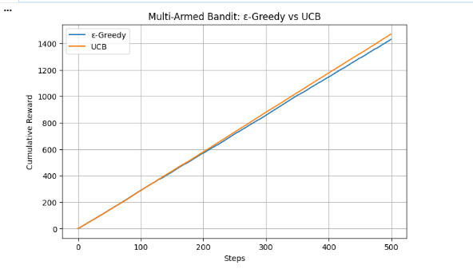
Result:
The Multi-Armed Bandit problem was successfully implemented using ε-Greedy and UCB algorithms. The cumulative rewards obtained by both methods were evaluated successfully.
Experiment 8: Reward Visualization in Reinforcement Learning

Aim:
To simulate an RL agent in a simple environment and visualize cumulative rewards, episode rewards, and learning performance using Matplotlib graphs.

Procedure :
- Simulate an RL agent for multiple episodes.
- Generate rewards for each episode.
- Calculate cumulative rewards.
- Store the reward values.
- Plot episode rewards using Matplotlib.
- Plot cumulative rewards using Matplotlib.
- Analyze the generated graphs.

Code:
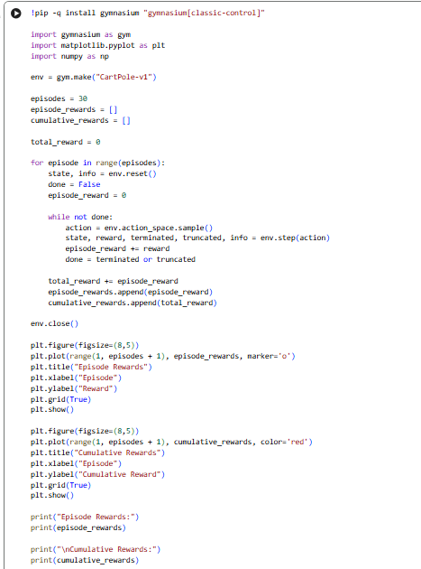
Output :
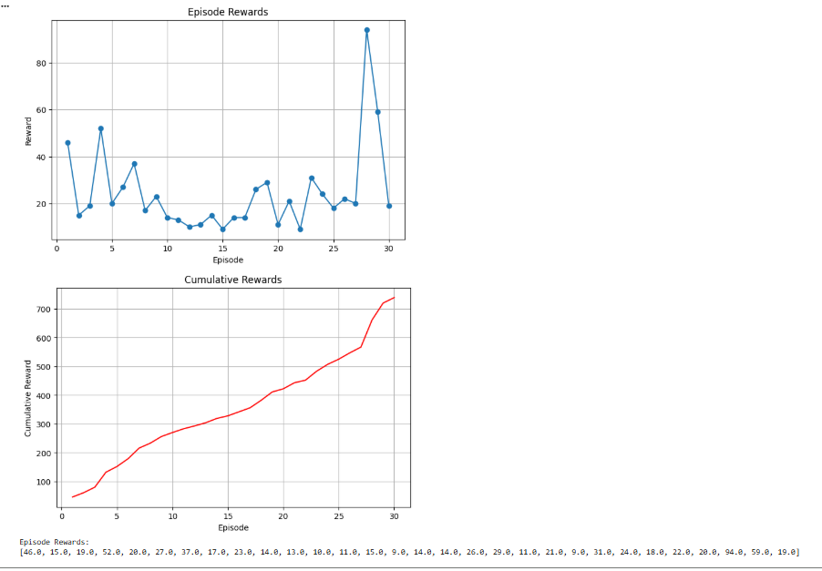

Result:
The RL agent's rewards were successfully visualized using Matplotlib. The graphs clearly illustrated episode rewards, cumulative rewards, and learning performance.

Experiment 9: TensorFlow and Keras-Based Neural Network for RL

Aim: To build a simple feed-forward neural network using TensorFlow and Keras for approximating value functions in Reinforcement Learning environments.

Procedure :
- Import TensorFlow, Keras, and NumPy.
- Prepare sample state-value training data.
- Build a feed-forward neural network.
- Compile the model using the Adam optimizer.
- Train the neural network.
- Predict the value of a new state.
- Display the predicted value.

Output :
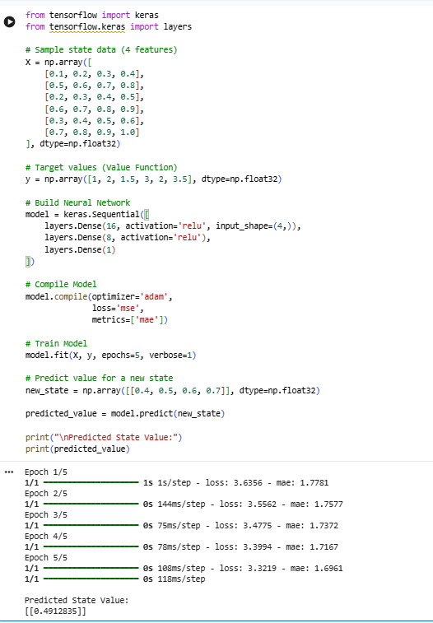

Result:
A feed-forward neural network was successfully developed using TensorFlow and Keras. The model learned the sample data and predicted the value function for a new state.

Experiment 10: Mini Reinforcement Learning Project Using CartPole

Aim:
To develop a basic Reinforcement Learning agent using TensorFlow and Keras to solve the CartPole environment and evaluate its learning performance through episode rewards and success rate.

Procedure :
- Import Gymnasium, TensorFlow, Keras, and NumPy.
- Create the CartPole-v1 environment.
- Build a neural network model.
- Initialize the RL agent.
- Execute multiple training episodes.
- Record the episode rewards.
- Calculate the success rate and evaluate the learning performance.

Output :
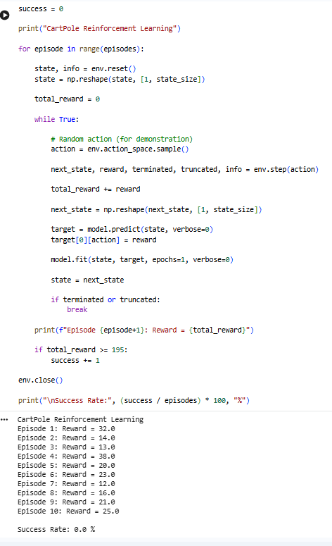
Result:
A basic Reinforcement Learning agent was successfully developed for the CartPole environment. The agent interacted with the environment, collected episode rewards, and its performance was evaluated using the success rate and reward obtained.

